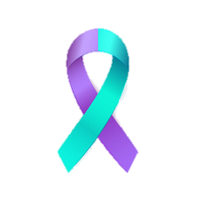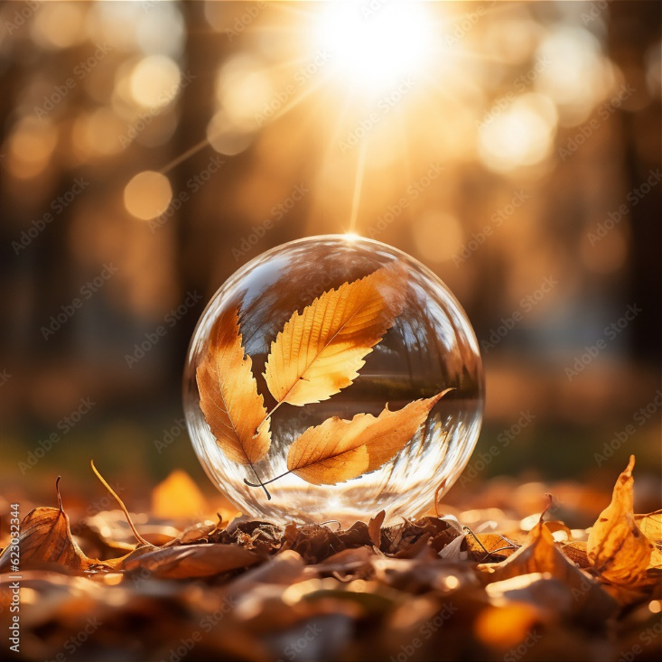**September National Suicide Prevention Awareness Month:**

**According to National Alliance for Mental Illness, 1 in 5 individuals in the United States suffer from mental illness. Most individuals suffer in silence and feel uncomfortable asking for help. Medical providers suggest that September is recognized as the highest numbered of suicide rates in America including young children and teens. Our emotions can disrupt our daily lives and become overwhelming in such feelings of despairation and hopelessness. Contributing factors to suicide can be related**  **to substance abuse, physical health, financial stress, and legal issues. It is important to know what to look for in suicidial behaviors and how to help. If you or someone you know are considering suicide please contact the National Suicide Prevention Lifeline at 988 by phone or text or 911 for your local emergency responders.**

**Warning Signs:**

* **Sudden drop in grades**
* **Creating threat plans with intent**
* **Feeling like a burden**
* **Increased anxiety**
* **Mood changes: becoming withdrawn, easily angered, sleeping, more aggressive**
* **Giving away possessions**
* **Participating in substance or alcohol use**

**Protective Factors:**

* **Seek support person**
* **Find new hobbies**
* **Keep healthy diet and water intake**
* **Talking to medical provider**
* **Be present**
* **Participating in physical activities: walking, fitness, or cycling**
* **Follow-up**

**Seasonal Affective Disorder: “More Than Just The Winter Blues”**

**A subtype of major depressive disorder with a seasonal pattern also known as Seasonal Depression. This is a recognized type of depression that is affected with the change of the year. SAD begins in young adulthood and occurs in more women than men. Mostly affected by northerners regionally, the disorder is displayed when daylight hours are shorten during fall and winter months and trigger a chemical in the brain that causes symptoms of depression. Seek professional help if experiencing any of the presented symptoms for collaborative treatment options.**

**Recognized signs of depression includes:**

* **Feeling sad**
* **Changes in appetite**
* **Thoughts of suicide/death**
* **Decreased energy**
* **Difficulty concentrating**
* **Physical aches: headaches, cramps, joint pain, and digestive issues**
* **Social withdrawing**

For help finding treatment, visit [NIMH’s Help for Mental Illnesses webpage](https://www.nimh.nih.gov/health/find-help).If you or someone you know is in immediate distress or is thinking about hurting themselves, call or text the [988 Suicide & Crisis Lifeline](https://988lifeline.org/)  at **988**or chat at [988lifeline.org](https://988lifeline.org/) .

**Effective Strategies**

* **Get as much sunlight as possible**
* **Participate in regular exercise**
* **Medication management including vitamins**
* **Maintain a healthy and balanced diet**
* **Avoid triggers and stressful situations/environments**
* **Increase water intake**
* **Face your fears**

